EXP 1 – PASSPORT AUTOMATION SYSTEM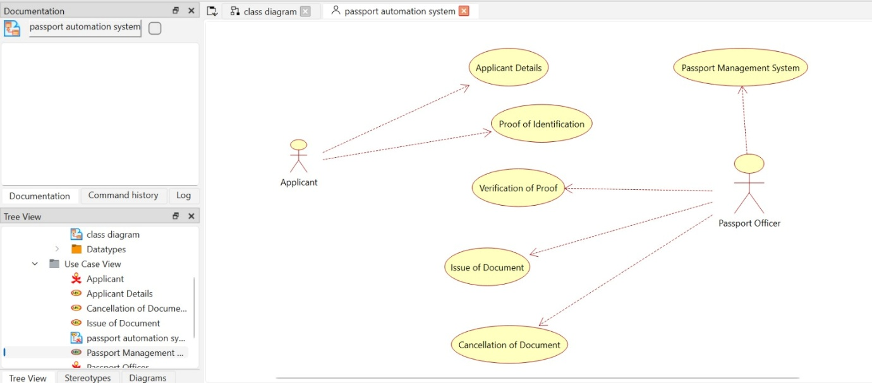
EXP 2- BOOK BANK MANAGEMENT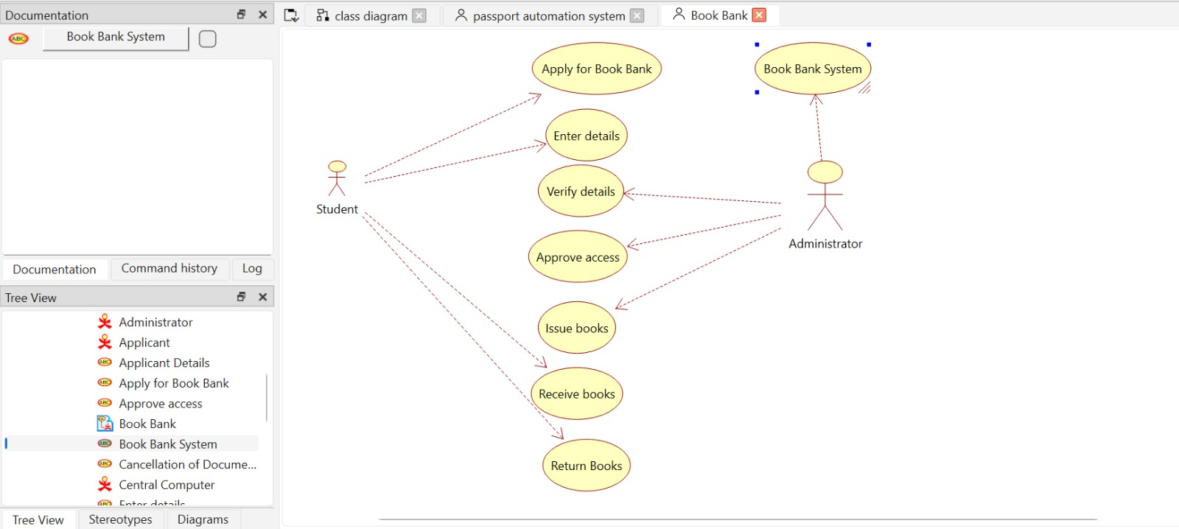

EXP 3- EXAM REGISTRATION SYSTEM
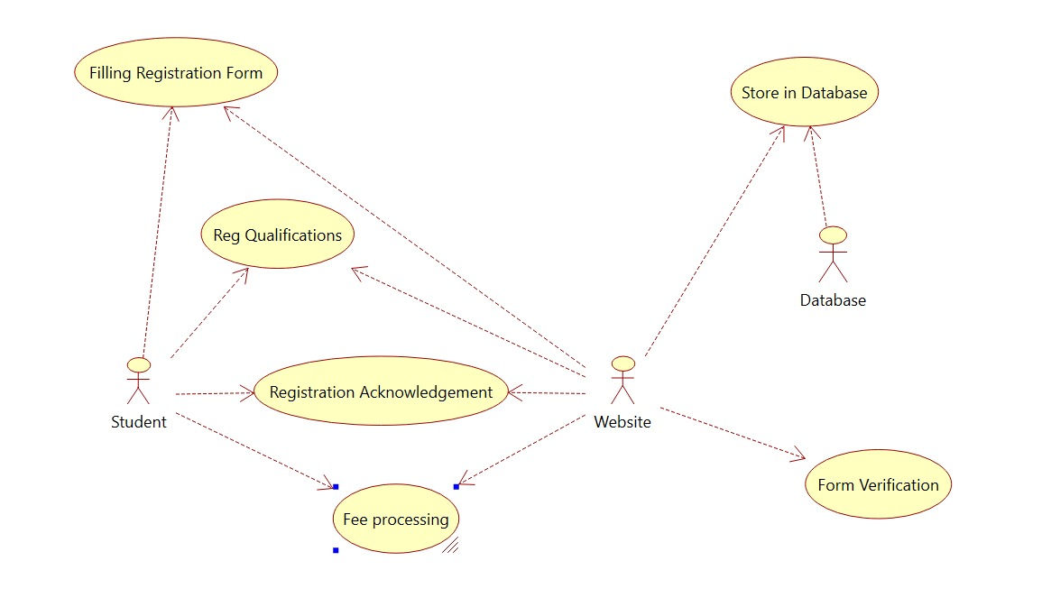
EXP 4- STOCK MAINTANCE SYSTEM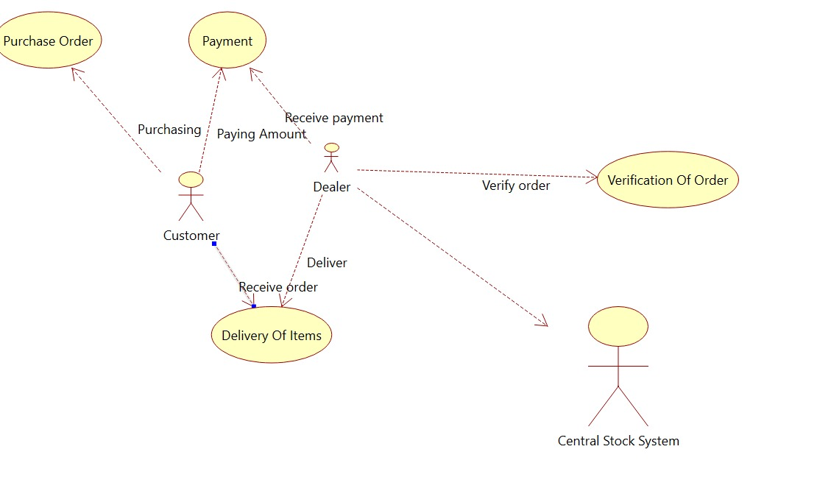

EXP 5- ONLINE COURSE REGISTRATION
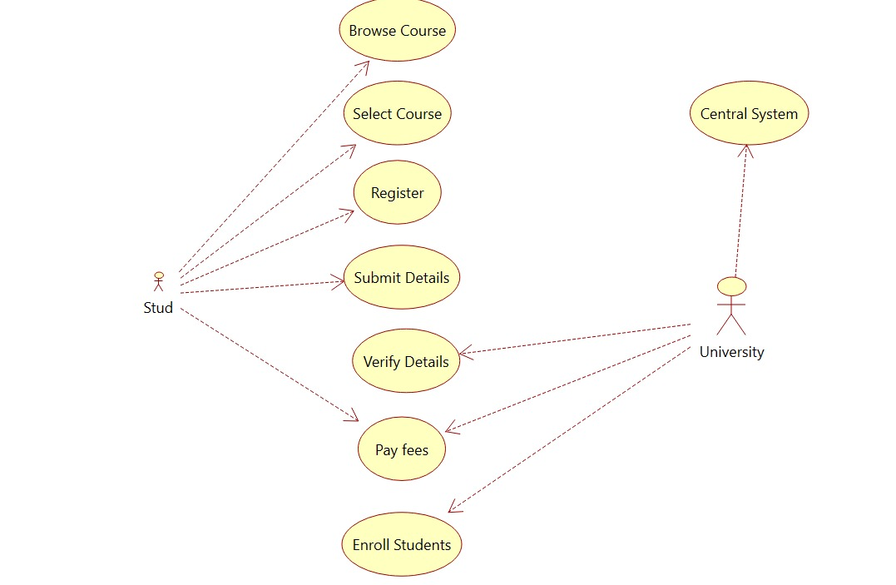
EXP 6- E-TICKETING SYSTEM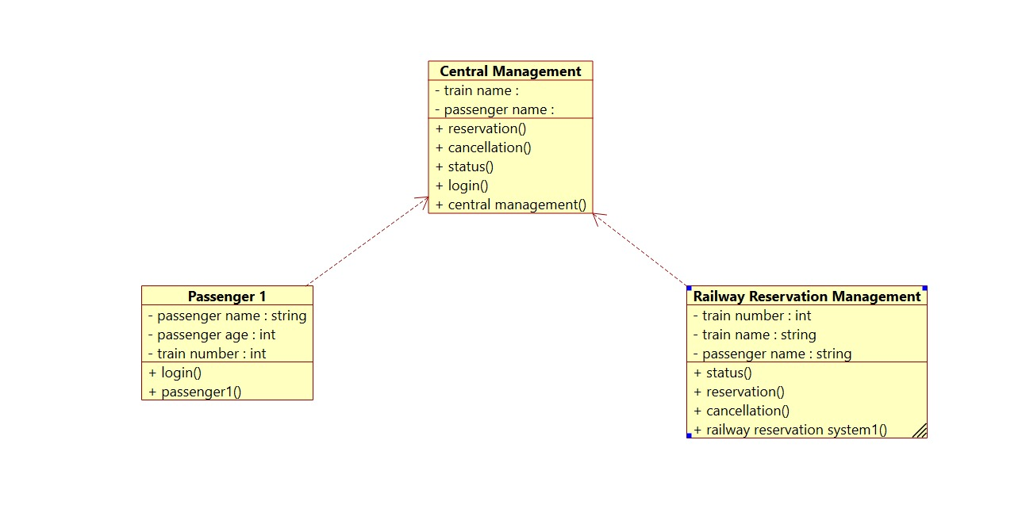
EXP 7- CREDIT CARD PROCESSING SYSTEM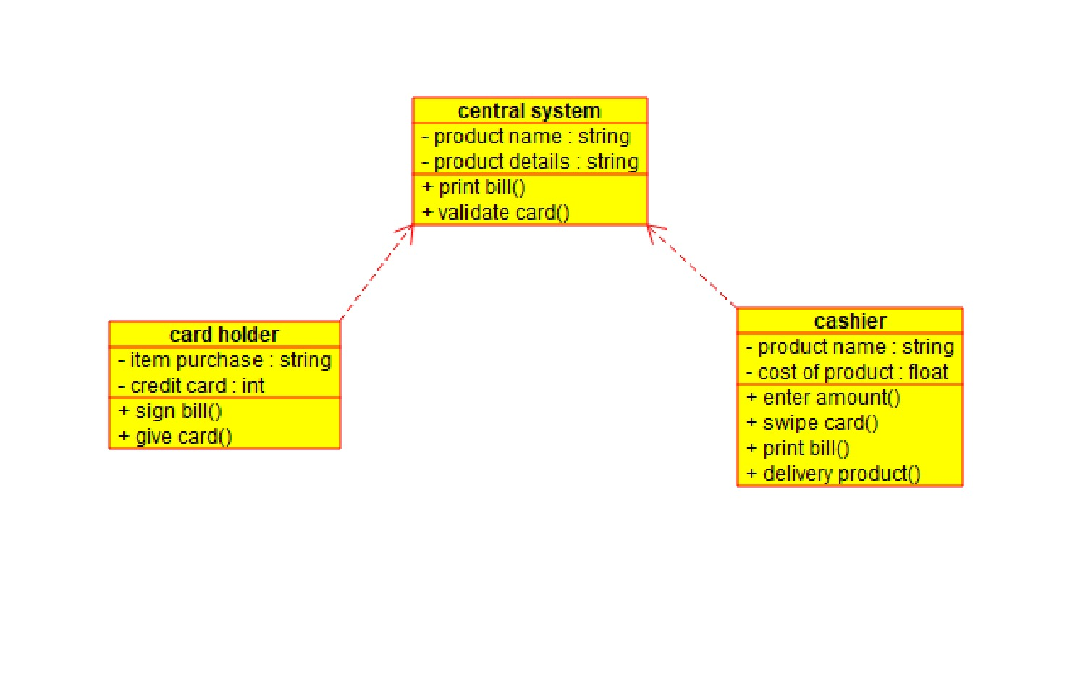EXP 8- SOFTWARE PERSONAL MANAGEMENT SYSTEM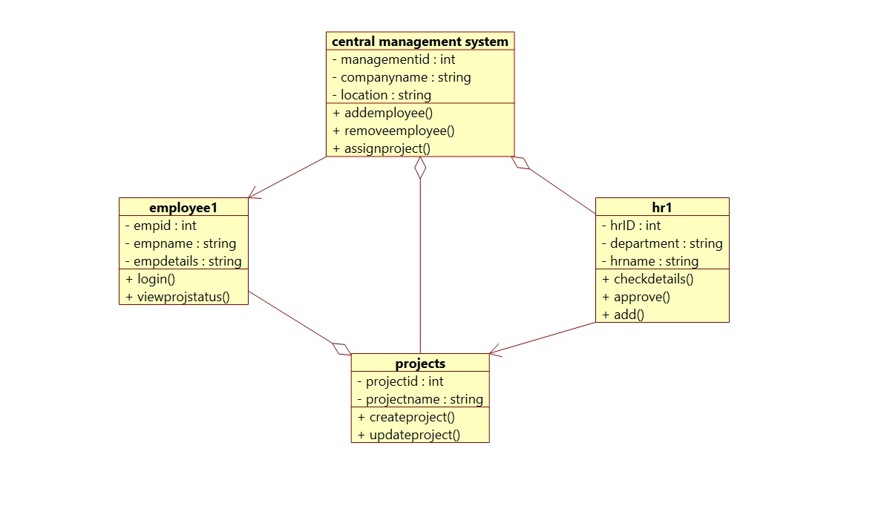

EXP 9- E-BOOK MANAGEMENT SYSTEM
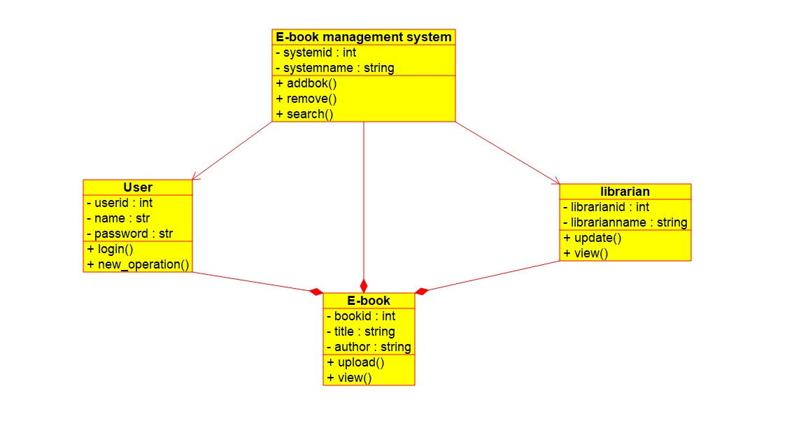
EXP 10 – RECRUITMENT SYSTEM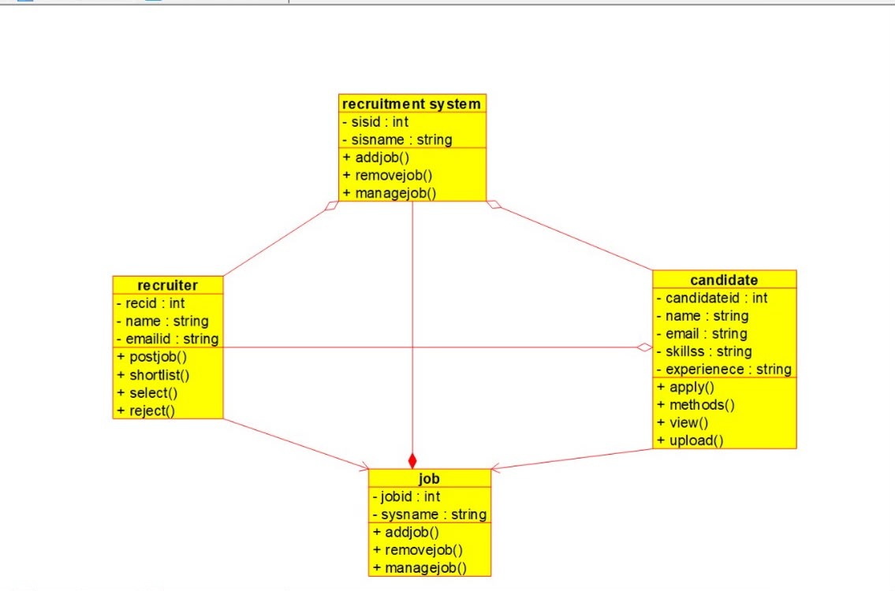

EXP 11- CONFERNCE MANAGEMENT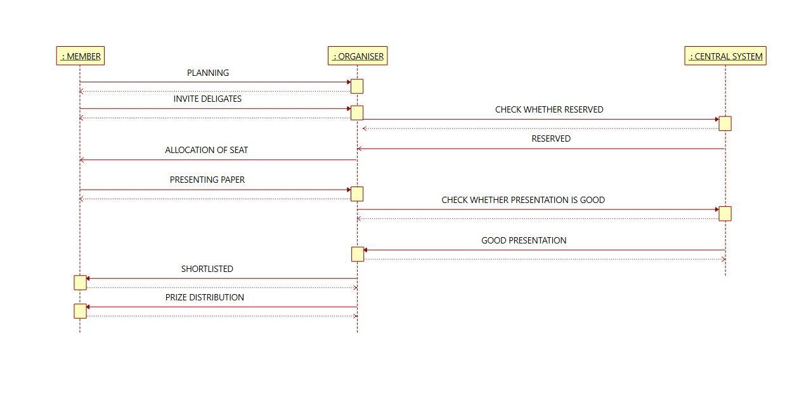
EXP 12- FOREIGN TRADING SYSTEM
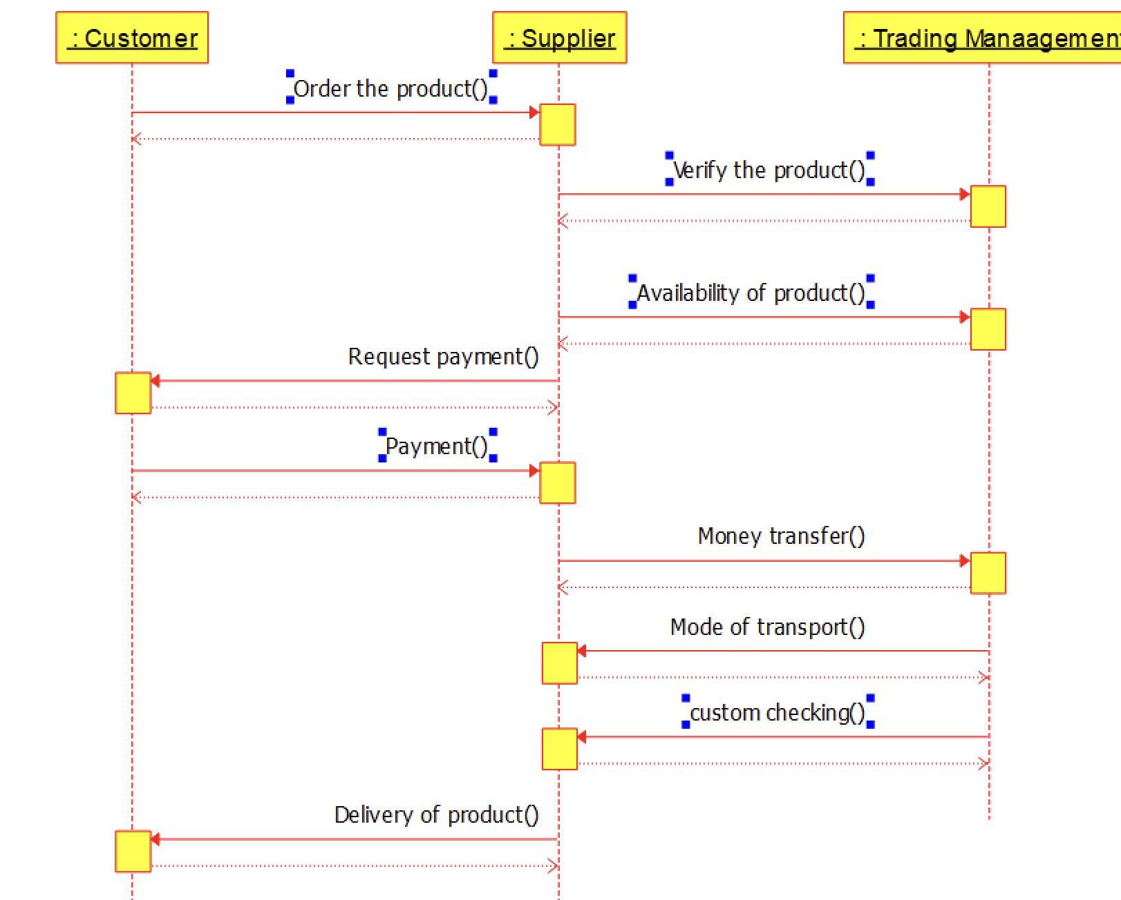
EXP 13- BPO MANAGEMENT SYSTEM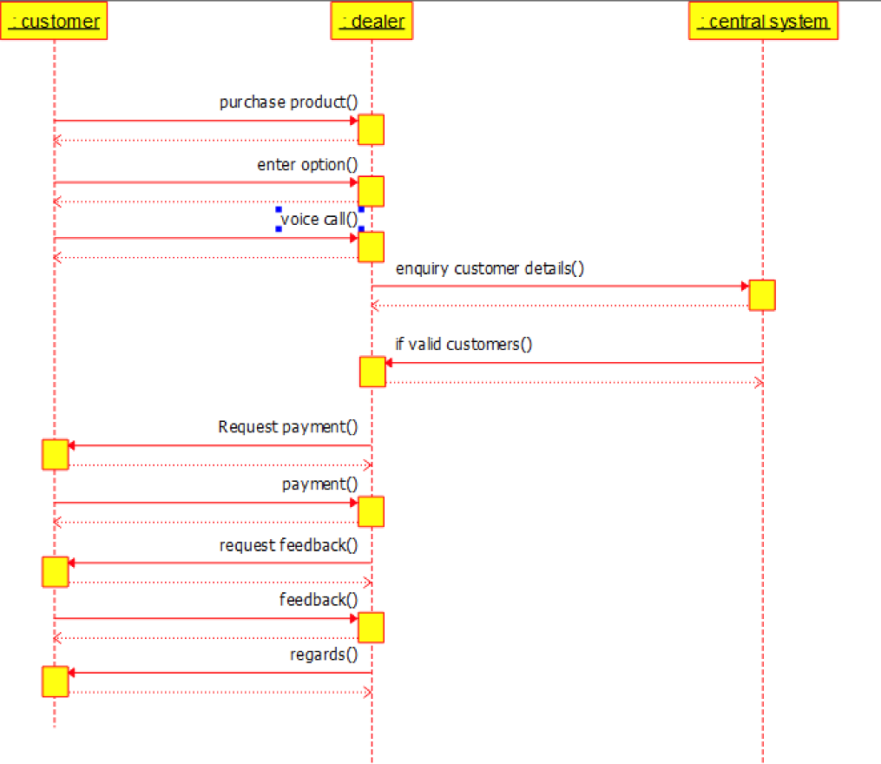
EXP 14- E-COMMERCE REGISTRATION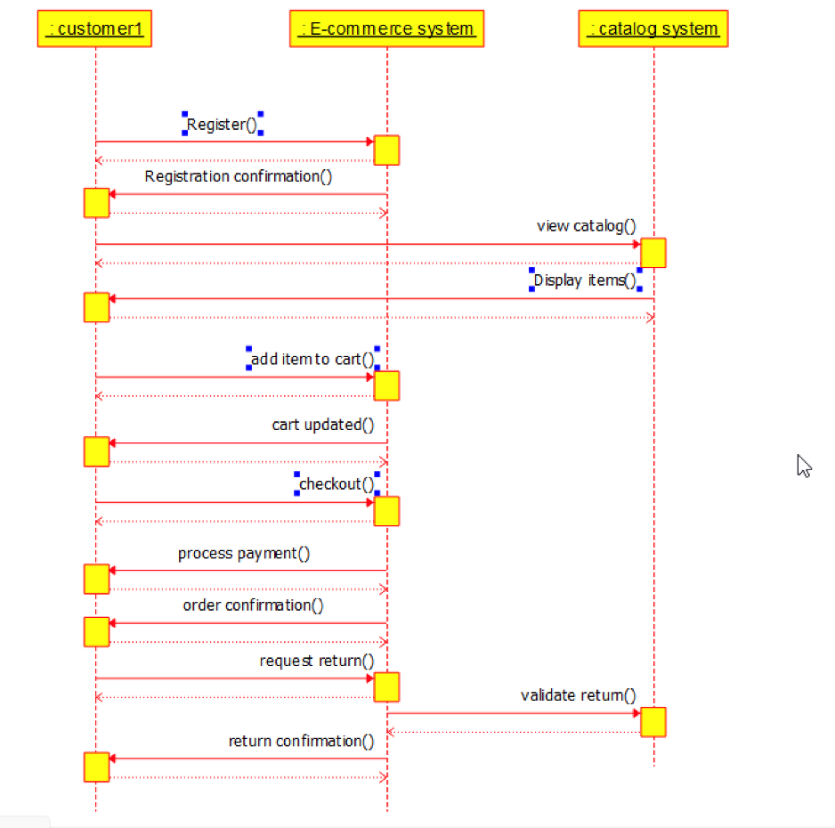
EXP 15-BLOOD BANK REGISTRATION